Please click here to download high-res photos.

Press release
For Immediate release

HKSTP Tackles Hong Kong’s Critical Ageing Society Challenge at
Gerontech and Innovation Expo cum Summit (GIES) 2023
Driving Ecosystem Growth with broader gerontech development and adoption

- GIES, now in its 7th year, is gathering key stakeholders to help establish Hong Kong as an age-friendly city
- Largest ever HKSTP pavilion themed “Age Smarter with Hub of Gerontech” features 50 gerontech partners showcasing innovative products and solutions
- Hong Kong facing challenge of more than one in three Hong Kong people being elderly by 2046

(Hong Kong, 23 November 2023) – The seventh annual Gerontech and Innovation Expo cum Summit (GIES), co-organised by Hong Kong Science and Technology Parks Corporation (HKSTP), kicks off today at the Hong Kong Convention and Exhibition Centre. The HKSTP pavilion this year is the largest since the first GIES in 2017 and features innovative products and solutions from 50 gerontech partners driving Hong Kong’s gerontech development to address the city’s ageing population challenge.

Co-hosted by the HKSAR Government and the Hong Kong Council of Social Service (HKCSS) and co-organised by HKSTP, GIES has evolved from a gerontech public education event into the largest gerontech platform, enabling engagement and collaboration among stakeholders to drive policy, societal, technology and economic developments in Hong Kong. Besides physical exhibitions, GIES also serves as a matchmaking platform for lead generation, with the ultimate goal of improving care and the quality of life for the elderly and establishing Hong Kong as an age-friendly city. This year, GIES is taking place from 23 to 26 November 2023 at Hall 1A-C, Hong Kong Convention and Exhibition Centre, showcasing almost 800 innovative solutions from more than 200 exhibitors, a two-fold increase since 2017.

Dr Sunny Chai, Chairman of HKSTP, said, “HKSTP is honoured to be a co-organiser of the flagship GIES event for the seventh consecutive year, in a collaborative effort to build a smarter and more age-friendly city using gerontech. Hong Kong faces the pressing challenge of a rapidly ageing society, and I believe gerontech is an effective solution. With a vibrant gerontech ecosystem comprising over 70 companies, HKSTP will continue to improve elderly wellbeing and the healthcare system by fostering collaboration across the government, industry, academia, and research sectors.”

Themed “Age Smarter with Hub of Gerontech”, the HKSTP pavilion rallies 43 Park companies to showcase gerontech innovations across seven categories, namely health screening; vital sign monitoring; rehabilitation and cognitive care; fall risk management and anti-wandering; service operations; tech-enabled care; and sensory aids. With a gross floor area of 500 sqm, the HKSTP pavilion becomes the largest pavilion ever since the first GIES in 2017. This year, InnoHK is also joining our Park companies’ efforts to participate at GIES for the first time. Seven InnoHK centres, including three from Health@InnoHK and four from AIR@InnoHK, are showcasing their pioneering gerontech solutions at the “InnoHK Zone”, which is located next to the HKSTP pavilion.

To enhance first-hand experience and end-user engagement, HKSTP has set up an interactive zone themed “Rehab@Home” inside the HKSTP pavilion, where a home-setting scene is set up to illustrate 13 rehabilitation products and solutions for home use. A cohort of “Gerontech Ambassadors”, comprising of physiotherapy students from Tung Wah College and elderly ambassadors from Lingnan University’s “Jockey Club Gerontechnology and Smart Ageing Project”, are stationed to share their own experience of these user-friendly solutions.

The global pace of population ageing is much faster than in the past. According to the United Nations, the total number of people aged 65 and above will increase from 10% of the world's population in 2022 to 16% by 2050. The challenge is more pressing in Hong Kong, as the Census and Statistics Department projected that the proportion of elderly people will increase from 20.5% in 2021 to 36% in 2046, meaning more than one in every three Hong Kong people will be elderly.

To accelerate solutions to this far-reaching issue, the Policy Address 2023 announced that the scope of expansion for the “Innovation and Technology Fund for Application in Elderly and Rehabilitation Care” will cover gerontech products suitable for home use. HKSTP is also growing its gerontech ecosystem to accelerate the development and adoption of life-changing and high-touch innovative technology to support the older generation and the healthcare system. New initiatives rolled out by HKSTP this year include a gerontech summer internship programme to provide internship opportunities for 15 service talents (Physiotherapy and Applied Gerontology students from Tung Wah College) in nine Park companies.

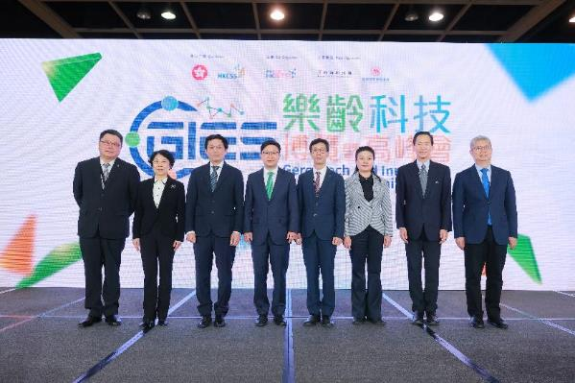
Photo 1: HKSTP co-organised the Gerontech and Innovation Expo cum Summit (GIES) 2023 with the HKSAR Government and The Hong Kong Council of Social Service. Officiating guests at the opening ceremony included:
- Chris Sun, Secretary for Labour and Welfare, HKSAR Government (fourth from left)
- Hon Wai, Director, Social Welfare Bureau, HKSAR Government (fourth from right)
- Zhou He, Deputy Director-General, Department of Social Affairs, Liaison Office of the Central People's Government in the HKSAR (third from left)
- Xiong Ying, Director, Civil Affairs Bureau of Shenzhen Municipality​ (third from right)
- Yi Lihua, Second-level Inspector, Guangzhou Municipal Bureau of Civil Affairs​ (second from left)
- Bernard Chan, Chairperson, The Hong Kong Council of Social Service​ (second from right)
- Dr Sunny Chai, Chairman, Hong Kong Science and Technology Parks Corporation​ (first from left)
- Zhang Junli, Executive Director, China Merchants Foundation (first from right)

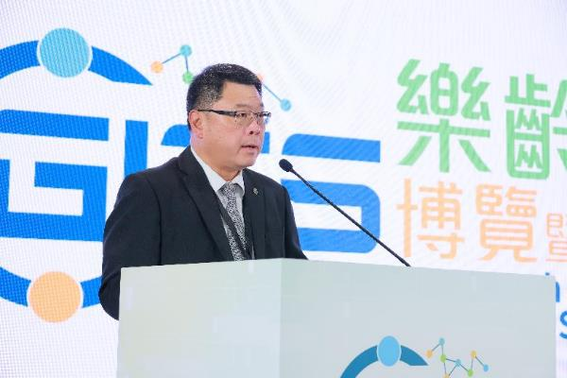
Photo 2: Dr Sunny Chai, Chairman of HKSTP, delivered a speech at the opening ceremony of GIES 2023, emphasising the implications of an ageing population as a matter of public concern, and illustrating how gerontechnology can improve elderly care and the social healthcare system.

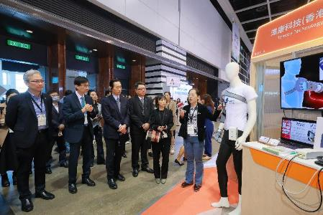 | 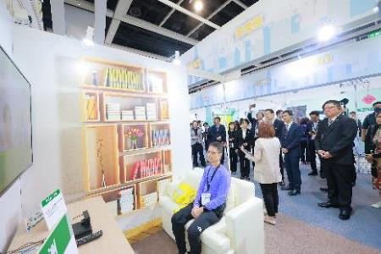
Photos 3-4: Dr Sunny Chai, Chairman of HKSTP, and other officiating guests joined the VIP guided tour to visit various thematic pavilions at GIES 2023, including the “Age Smarter with Hub of Gerontech” pavilion of HKSTP, “Smart & Healthy Ageing” Pavilion, “Tele-practice Platform”, “GTP - Testing Ground” and “Care Food Pavilion”.

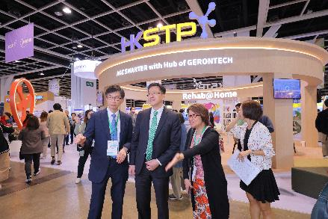 | 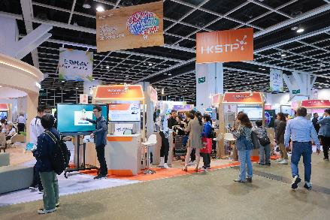
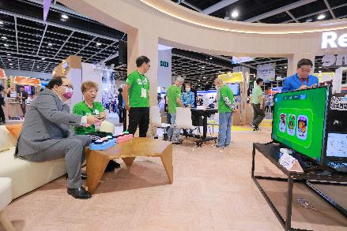 | 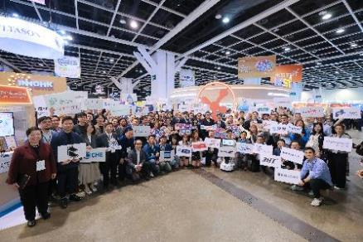
Photos 5-8: “Age Smarter with Hub of Gerontech” is the largest HKSTP pavilion ever since the first GIES in 2017, featuring cutting-edge products and solutions from 50 gerontech partners.

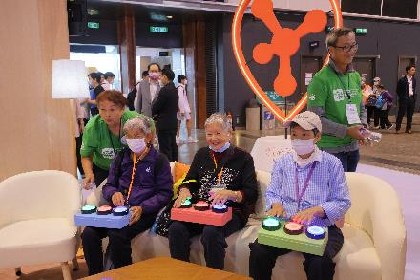 | 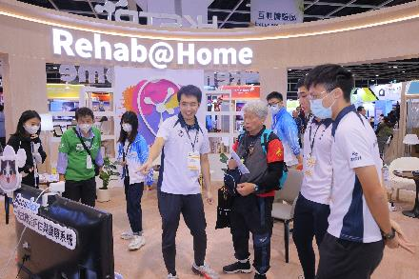
Photos 9-10: HKSTP’s “Rehab@Home” interactive zone is a demonstration of cross-generational integration. Comprised of physiotherapy students from Tung Wah College and elderly individuals from Lingnan University’s Elder Academy, “Gerontech Ambassadors” joined hands to demonstrate the vast potential of scaling smart rehab tech from institutions to homes.
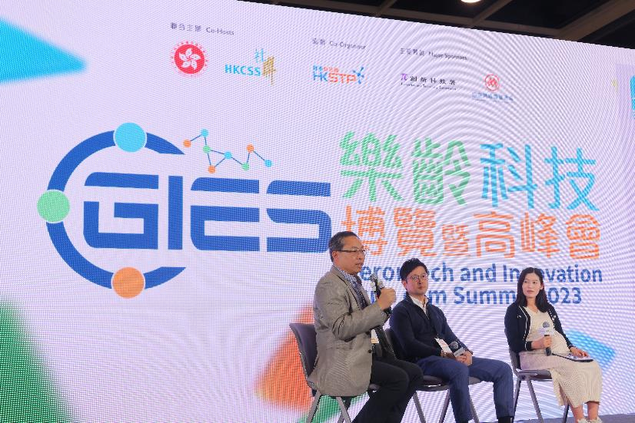
Photo 11: Park company representative Mr Gordon Lee, Vice President of Booguu Company Limited (left), shared how gerontech contributes to the advancement of services in NGOs.

List of Park Companies and InnoHK Centres Exhibiting at GIES 2023 (in alphabetical order):
*Please refer to the appendix for detailed product descriptions and photos
- ADD CARE LIMITED  - AI Guided Limited  - Andesfit System Limited  - Applied Technology Group Limited  - Belun Technology Company Limited  - BNET-TECH Company Limited  - Booguu Company Limited  - Capmi Technology Limited  - Carewells Limited  - Centre for Eye and Vision Research (CEVR)  - Centre for Intelligent Multidimensional Data Analysis Limited (CIMDA)  - Centre for Perceptual and Interactive Intelligence (CPII)  - Cognitact Limited  - Comfit Healthcare Devices Limited  - DRESIO Limited  - Fung Fat Knitting Mfy Ltd  - Genieland Company Limited  - Growgreen Limited  - Hong Kong Centre for Cerebro-cardiovascular Health Engineering (COCHE)  - Hong Kong Center for Neurodegenerative Diseases (HKCeND)  - Hong Kong Kairuipu Medical Technology Co,. Limited  - Hong Kong Univisual Intelligent Technology Limited  - Hopebotics Limited | - iASPEC Services Limited  - Incus Company Limited  - Infiniti Solutions Limited  - InnoSpire Technology Limited  - Intelligent Design Technology Limited  - Kin Technology Limited  - Laboratory for Artificial Intelligence in Design (AiDLab)  - Laboratory of Data Discovery for Health (D²4H)  - MaxiSense IoTech Limited  - Medmind Technology Limited  - Mindvivid Limited  - Novelte Robotics Limited  - PanopticAI Limited  - Parami Co. Limited  - Qleap Business Solutions Limited  - RHT Industries Limited  - Robocore Technology Limited  - RV Automation Technology Company Limited  - Sharpsight Limited  - Skytech Creations Limited  - Smart Bright Technology Enterprises Limited  - Superior Autonomation Ltd  - Thecon Technology (HK) Limited  - ThingX Technologies Limited  - Titanology Ltd  - We Software Limited  - Well Being Digital Limited

###
About Hong Kong Science and Technology Parks Corporation
Hong Kong Science and Technology Parks Corporation (HKSTP) was established in 2001 with a mission to position Hong Kong as an international innovation and technology (I&T) hub. HKSTP has created a thriving I&T ecosystem supporting over 10 unicorns with more than 13,000 research professionals and over 1,500 technology companies from 24 countries and regions focused on healthtech, AI and robotics, fintech and smart city technologies.

We offer comprehensive support to attract and nurture talent, accelerate and commercialise innovation for technology ventures on their I&T journey. Our growing innovation ecosystem is built around our key locations of Hong Kong Science Park in Shatin, InnoCentre in Kowloon Tong and three modern InnoParks in Tai Po, Tseung Kwan O and Yuen Long. The three InnoParks are realising a vision of new industrialisation for Hong Kong, where sectors including advanced manufacturing, micro-electronics and biotechnology are being reimagined for a new generation of industry.

To support Hong Kong’s future development and its growing demands of the I&T industry, HKSTP is actively connecting the city with Shenzhen. This aims to strengthen cross-border exchange, attract technology companies as well as talent from around the world, helping them go global by exploring the mainland China and overseas markets.

Hong Kong Science Park Shenzhen Branch in Futian, Shenzhen, opened in September this year with a gross floor area of 31,000 square meters. The two buildings provide both dry and wet laboratories, co-working areas, conference and exhibition spaces, and more. We will focus on attracting enterprises in seven key areas: Medtech, big data and AI, robotics, new materials, microelectronics, fintech and sustainability.

Through our infrastructure, services, expertise, and network of partnerships, HKSTP will help establish I&T as a pillar of growth for Hong Kong, while reinforcing the city’s international I&T hub status as a launchpad for growth at the heart of the GBA innovation powerhouse.

More information about HKSTP is available at www.hkstp.org.

Media Contact:
Hong Kong Science and Technology Parks Corporation  Claire Ma  Tel: +852 2629 7032  Email: claire.ma@hkstp.org | Edelman Public Relations  Sonia Leung  Tel: +852 2837 4775 / +852 9684 9460  Email: Sonia.Leung@edelman.com / Edelmanhkstppr@edelman.com

